# INSTALLING VS COMMUNITY 2022

First of all, go to chrome or any internet browser search VS COMMUNITY 2022

Click on the link and go to next page scroll down.

Click download button what do you want on the basics of usage.

1.After download click the exe file, and download it then install all the file in your file explorer and also set the path.

2. After completing the installation set up

3.Go to search button in your device, search- vs installer then below window appears

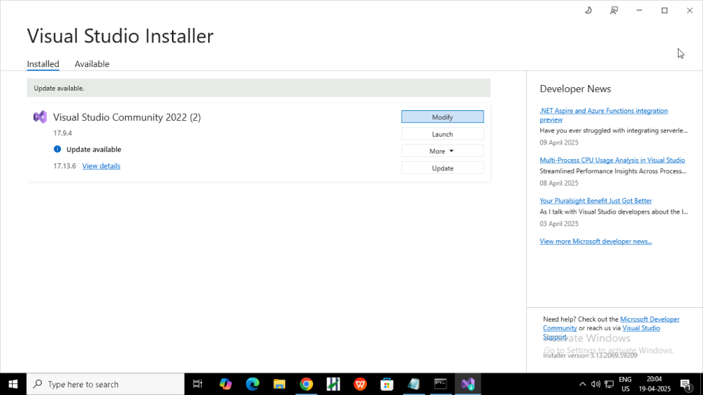

click modify button then.

Install what are the essential package in your project.

* Install and downloading.
* Wait some minute to download all files.
* Then download compiler.

Here my compiler is MINGW because I use C++ language for my windows projects.

Steps for downloading compiler and set the path to the compiler in environment.

* First go to search button type ” Edit the system environment variables”

* Open the file then you can see below window.

* Click “environment variable” then next window appears.
* Before you go to next window you do below step.
* Go to file explorer -> open the MINGW download file ->copy the path.
* That window we can set our path A screenshot of a computer

  AI-generated content may be incorrect..
* Click the path.
* Click below first edit button you can see below window

* Click “New” so new line comes.
* Than go to paste here the path you copied , click ok .

After finished all setup we can go to open VS COMMUNITY to create an project

# CREATING NEW PROJECT IN VS COMMUNITY 2022

I am going to create a project using VS COMMUNITY 2022, because my project tools, themes are available here.

Open VS COMMUNITY 2022

* Click on “create a new project” here we can use create a new project.
* While click “open a local folder” we can upload file, or project file creation also done.
* And” clone a repository” option also we can use to download repository then run or edit.

Here we can use “create a new project” because new project option help to study how to create, how we can link header files, bin folders etc.

We can study entire structure of CPP program and project.

While we create new project there are two types in VS COMMUNITY 2022.

* Console App.
* Empty project.

I use empty project ,because we want to build all files

* choose the language= CPP.
* Choose the platforms.
* Choose the project types.
* Click next.

* Give name to project here I give “hello”.
* Save the file so choose the path.
* Put tick or not as you wish.
* Click next.

Here our project file is created our all code ,bin, EXE.file , obj file,headers are stored.

Here the file we can create files based on your project requirement eg folder,files,bin,inc etc…

Click on the “hello “project name right click you can see below.

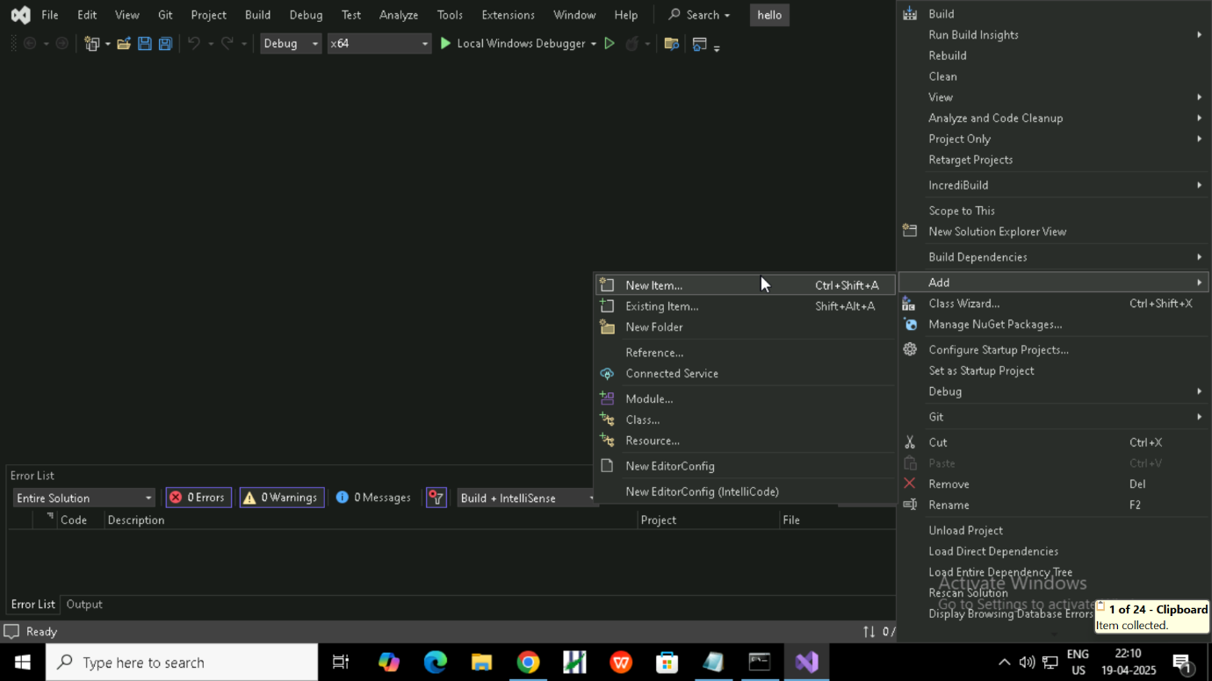

This is the way to create add files in your project. You can create any number of files, folders in your requirement. Inside file you can save the file. extension eg (cpp, html)in your file name and folder don’t need to extension.

Write your code inside the file here I write simple code for printing hello word.

To clean your project, follow the below step here we can build your project also

What we needed or any problem face you use here build.

After the process you can go to debugging

Debugging process is below:

Go to “debug “to find any bug in or code error in your code using!

Start debugging and start without debugging option to build or run your project.

Here your project run successfully…….

# Create a large project using VS COMMUNITY 2022

Now we discus how we create a large project using VS COMMUNITY 2022

Steps are:

* Create an empty or console project.
* Then select project type(window,desktop,web), language(cpp,java),platforms for run eg(64 or 32) .
* Give name to your project and choose the folder to save.
* Then create src file to store the cpp file(source ode).

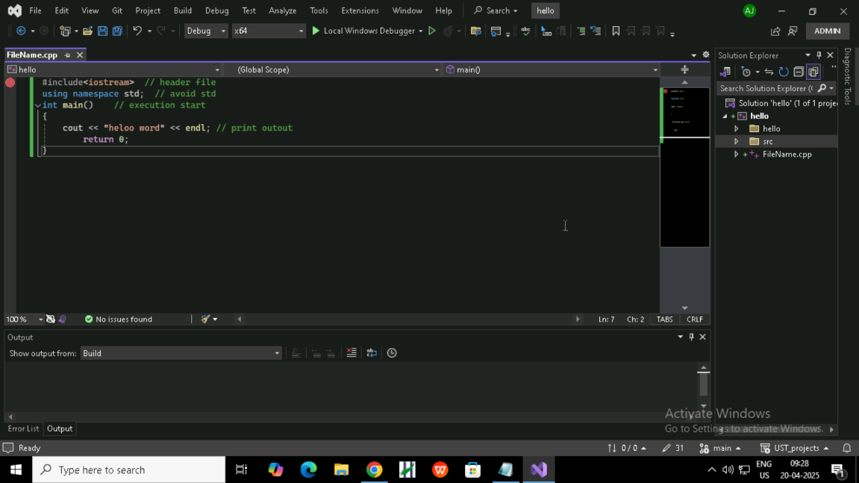

When you can create whole code inside the src file, you can create any number of cpp file as need your project.

Then your project have lot of header files,you can create an inc file “include”

Your project have lot of cpp file inc help to link each program .

Then click your project name and add a new folder name “inc”.

Then inside the inc folder you can store or create “.h” file here you can include all header file.

When you create an inc file you want to include the directory as shown below

You can see below inc folder and .h file.

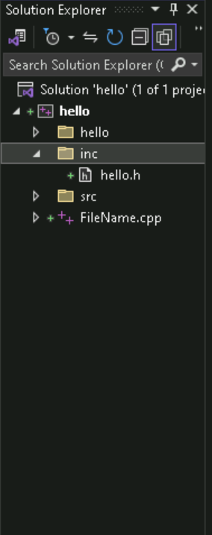

Then we go to add directory to add inc file path;

Click the project -> go to properties -> click “ c/c++” -> click “General” ->click “additional include Directories”

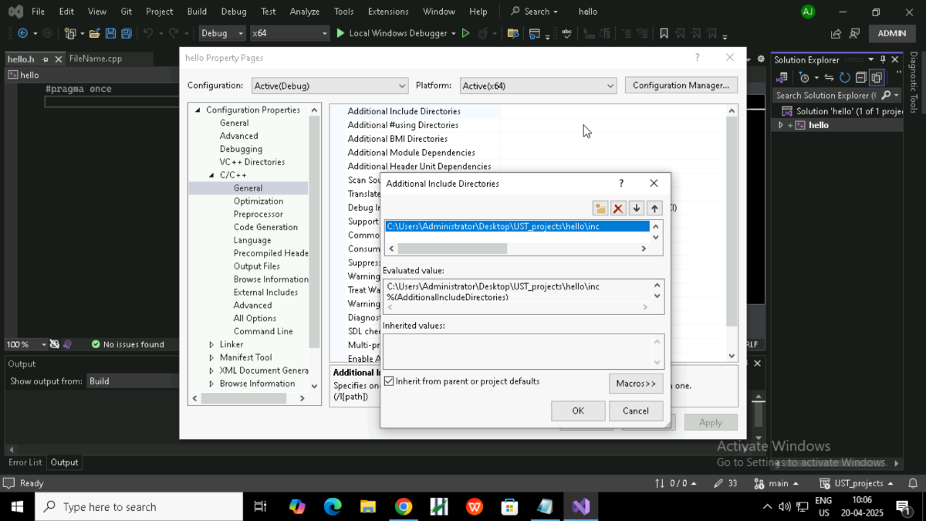

You can see again a window their you can click the folder button then you can add the

Folder path your “inc” then click “ok” then “apply”.

Here we add “inc”for header file then we can add the bin folder for save your project executable file”.exe”. the steps are below:

* Click on project -> create a bin folder->then click on “properties” you can see below window

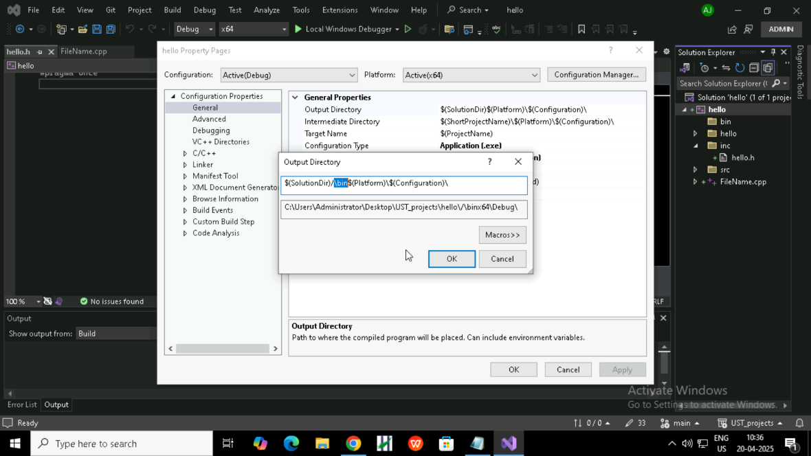

Then click on “General” you can see “General properties” click on it edit the path include for type bin as shown in the picture then click ok and apply

Here you can see the bin path, this is the way to create the structure of large project

# GITHUB

Github is a distributed version control you can push ,pull,edit,everything as needed to your project.you can store your project in the form of source code etc. like but you cannot store exe file.